Welcome to Allelogram

What is Allelogram?
Allelogram is a program that helps you find errors in microsatellite genotypes, bin microsatellite alleles to provide consistent data for downstream analysis, and normalize them for better binning.
Allelogram reads standard tab-delimited text files, using a description that you prepare.
Allelogram runs on Mac OSX and Windows, and probably runs on most variants of Unix, although it hasn’t been tested on those platforms. It requires Java 1.5; here is a link with helpful information for using Java 1.5 on Mac OSX:
http://docs.info.apple.com/article.html?artnum=301073

Downloads
You can download the latest version of Allelogram from the Yahoo group site:
http://tech.groups.yahoo.com/group/allelogram/
Allelogram is open source software, under the MIT License; the source code is available here:
http://code.google.com/p/allelogram/

Allelogram Walkthrough
Included with Allelogram are two files, example_file_format.txt and SW13.txt. These are plain text files that you can open in any text editor. The example_file_format.txt document describes the contents of SW13.txt; you will need to prepare a similar file format document to tell Allelogram how your own data files are organized. To learn how to prepare your own file format document, see the section Preparing a File Format Document beginning on Page 8. For the walkthrough, we will use the readymade documents.
Open Allelogram by double-clicking on the Allelogram.jar file. It opens a new, empty window. Before you can open a data file, you need to tell it the file format, so choose Pick File Format from the File menu, and select the example_file_format.txt document (Allelogram remembers your file format, so you only need to do this once – plus whenever you want to change it). Now choose Open from the File menu, and choose SW13.txt. Here is what the file looks like when you first open it:
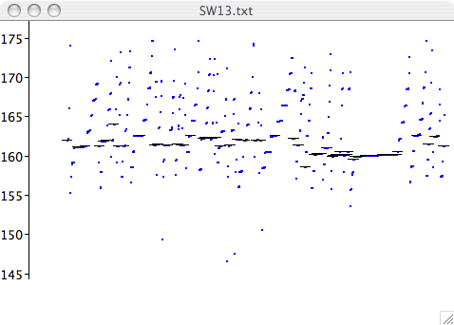
This represents all the alleles from the file, sorted (as specified in the file format document) by Run, and within Run by size. Alleles belonging to the designated control subject (LABID 99999) are emphasized by a short horizontal black bar; these alleles will be used for normalization. Do we need normalization? Choose by Size Only from the Sort menu; the chart now looks like this:
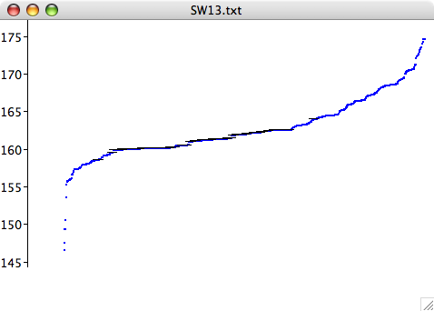
It’s very hard to see where to draw boundaries between alleles. We need normalization. Switch back to the original sort order by choosing by Run from the Sort menu, then choose Auto-Normalize from the Normalize menu.
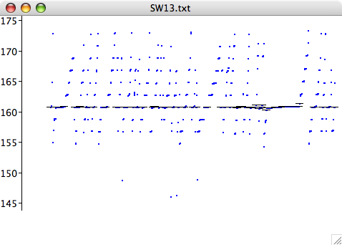
That looks better! If we sort by size only, we can see clean gaps between allele groups:
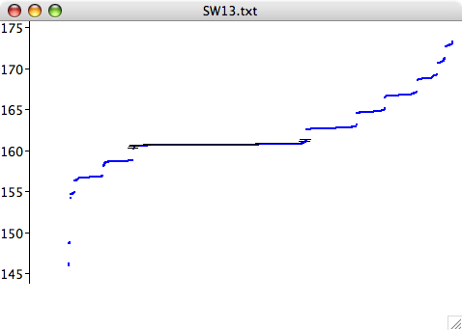
To see the normalization factors, sort by run again and choose Show Normalization from the Normalization menu.
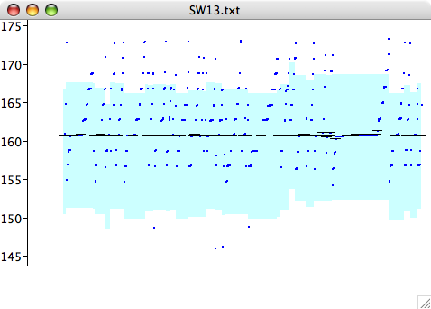
When you are showing normalization, you can drag the individual allele groups (runs, in this case) up and down to normalize manually.
The reason for normalizing was to be better able to bin the alleles, to identify the alleles that have the same actual size, notwithstanding measurement variations. So choose Guess Bins from the Bin menu. You can choose to name bins by size (147, 149, 151, …), by letter (A, B, C, …), or by index (1, 2, 3, …).
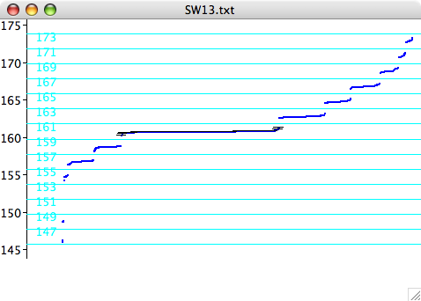
Now when you save the file (Save As on the File menu), the normalized allele sizes and the bins will be stored with the file, in new columns. That is what Allelogram is all about.
You can get information about a particular allele by clicking on it; the information shows up in the lower left corner of the window. The left and right arrow keys select adjacent alleles. Command (Control on Windows) and Option (Alt) clicking select entire runs.
You can zoom vertically by dragging down over the range you want to focus on; drag up to zoom back out. When you are showing normalization, dragging moves groups of alleles; to zoom while you are showing normalization, hold down the Command (Control on Windows) key as you drag.
Dragging bin boundaries up and down works, too.

Preparing a file format document
Here is the example file format document provided with Allelogram:
columns
Use
Comments
ID
SPNAME
Marker
LABID
instrument_ID
instrument_type
run_date
capillary
capillary_length
polymer
Call 1
Call 2
Allele 1
Allele 2
classifications
Lab ID: LABID
Instrument: instrument_type.instrument_ID
Run: run_date
sort
Run
color
Lab ID
info
Lab ID
Run
click
Run
Lab ID
control
Lab ID: 99999

The file format document is a plain text document; you can edit it with any word processor is grouped into sections; entries within the sections are indented by a tab. Please keep the sections in the order shown.
The columns section tells Allelogram, naturally enough, what the columns in the data file hold. Each row in this section identifies the corresponding column in the data files; the only restriction is that the columns holding allele sizes should be named “Allele 1” and “Allele 2” (and so on, for higher ploidies).
The classifications section puts the columns that are of interest to you into groups. Sometimes (as with LABID in the example) there is just one column in a classification; other times, multiple columns are grouped together. Instruments, for example, are represented by the instrument type, followed by a period, followed by the instrument ID.
The sort section holds one classification; this is the initial sort order for newly-opened files. The color section
The info section lists one or more classifications; these are the classifications that will be displayed, along with the allele values, when you click on an allele in the chart.
The click section identifies two classifications. The first of these is what will be selected when you hold down the Option (Alt on Windows) key as you click an allele; the second is what will be selected when you Command (Control on Windows) click. For the example file, Option-clicking an allele will select all alleles that share its run; Command-clicking selects all with the same Lab ID.
Finally, the control section identifies the control individual. It starts with the classification (in this case Lab ID), followed by a colon, followed by the control’s identity (in this case 99999). Allelogram will highlight the alleles of this individual and will use these alleles for automatic normalization; this should represent a sample that was genotyped on every run.

About the Example File
The example file comes from data generated by Sara Mesnick at NOAA’s Southwest Fisheries Science Center. It holds sperm whale genotypes generated over quite a long period of time, using at least 3 different technologies (ABI 373, 377, and 3100).

Contact Information
Get your Allelogram questions answered at the Yahoo group site
http://tech.groups.yahoo.com/group/allelogram/messages
or email me, Carl Manaster, at manaster@pobox.com

